
Kells Lane Primary School Sports Premium Plan 2024-25

This year, the school received £19,580.00 to invest in additional and sustainable improvements to the quality of PE and sport that we offer, as well as promoting healthy and active lifestyles across the school. Included in this will also be travel costs to and from sporting events as well as coaching and clubs. The following figures are a breakdown of how the sports premium budget has been spent from the period of 01/09/2024 – 31/07/25. Some costs appear multiple times as they cover several of the five key indicators.
Ofsted have stated there are five key indicators that schools should expect to see improvement across. The areas of focus are: the engagement of all pupils in regular physical activity; the profile of PE and sport is raised across the school as a tool for whole-school improvement; increased confidence, knowledge and skills of all staff in teaching PE and sport; broader experience of a range of sports and activities offered to all pupils and increased participation in competitive sport.

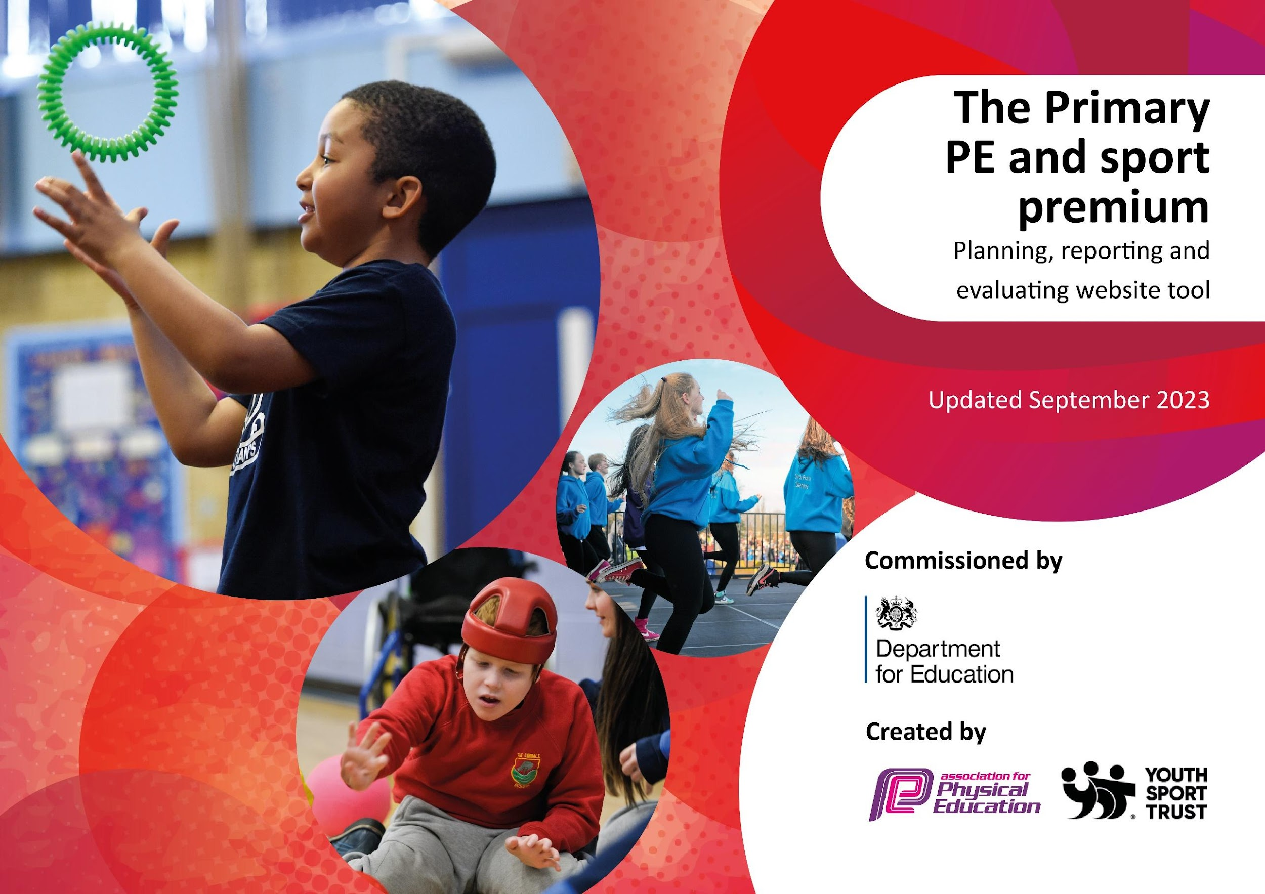

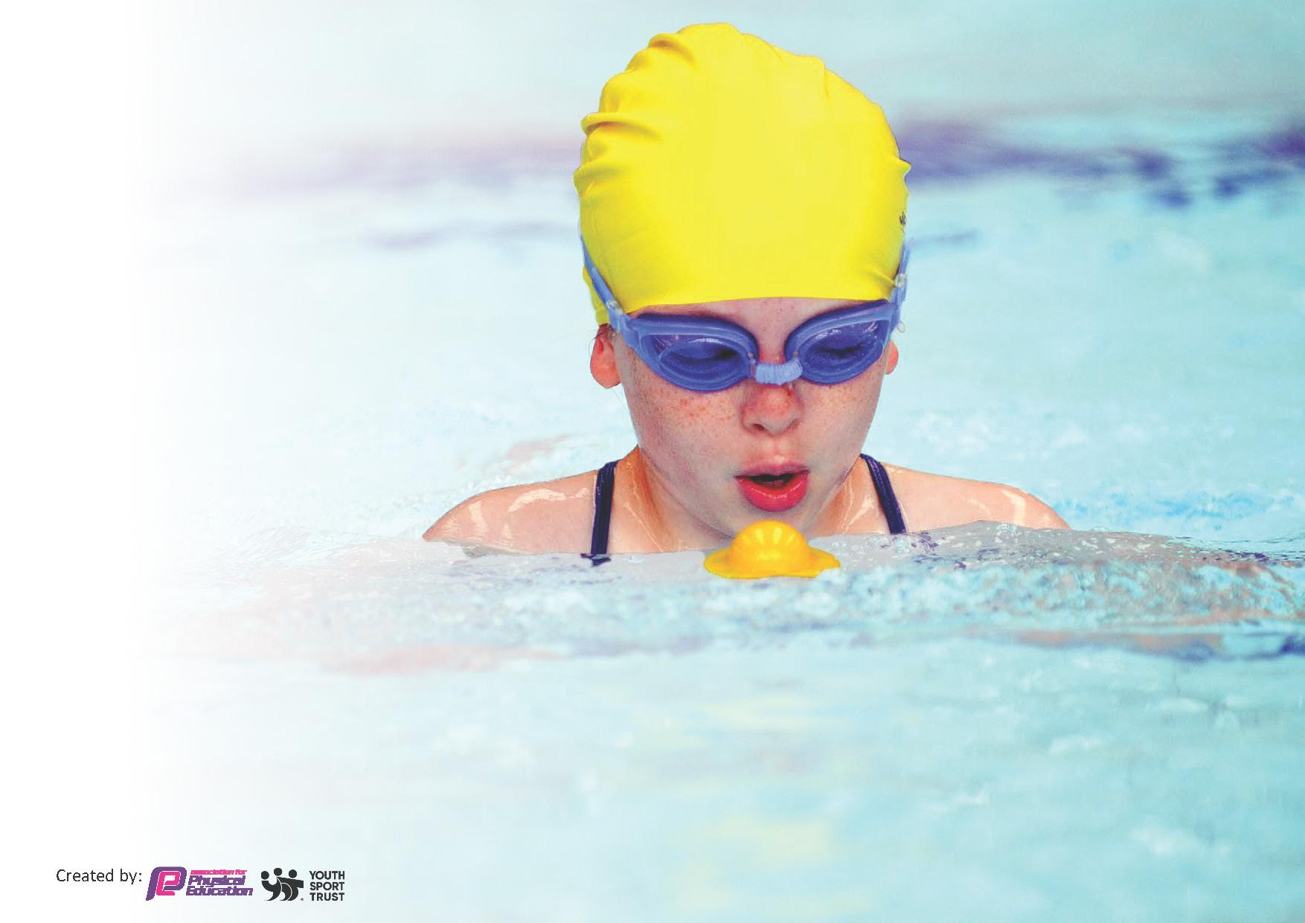
This template can be used for multiple purposes:
by:
- It enables schools to effectively plan their use of the Primary PE and sport premium
- It helps schools to meet the requirements (as set out in guidance) to publish information on their Primary PE and sport premium
- It will be an effective document to support Ofsted inspections enabling schools to evidence progress in Physical Education (PE) and evidence swimming attainment, which forms part of the PE National Curriculum. We would recommend schools consider
the Intent, Implementation and Impact of any spend, as examined within the Education Inspection Framework.

It is important that your grant is used effectively and based on school need.

Schools must use the funding to make additional and sustainable
improvements to the quality of the PE, School Sport and Physical Activity (PESSPA)
they offer. This means that you should use the Primary PE and sport premium to:

- Build capacity and capability within the school to ensure that improvements made now will benefit pupils joining the school in future years
- Develop or add to the PESSPA activities that your school already offers.

The Primary PE and sport premium should not be used to fund capital spend projects; the school’s core budget should fund these. Further detail on capital expenditure can be found in the updated Primary PE and sport premium guidance.

necessary that spending has to meet all the key priorities, you should select the priorities that you aim to use any funding towards.

Although completing this template is not a requirement for schools, schools are required to publish details of how they spend this funding. Schools must also outline what the impact this funding has had on pupils’ PE and sport participation and attainment and how any spending will be sustainable in the future. All funding must be spent by 31st July 2025.

The Department for Education has worked closely with the Association for Physical Education (afPE) and the Youth Sport Trust (YST) to develop this template and encourages schools to use it. This template is an effective way of meeting the reporting requirements of the Primary PE and sport premium.
Review of last year’s spend and key achievements (2023/2024)

We recommend you start by reflecting on the impact of current provision and reviewing your previous spend.

What went well? | How do you know? | What didn’t go well? | How do you know?
Applying for the Gold School Games Mark  SEN children taking part in more PE and lessons being adapted well.  Playing competitive sports against other schools.  Girls and boys football team in Year 6.  Winning the Gateshead’s basketball tournament.  A wide range of extra-curricular clubs offered to children.  SEN taking part in more PE and lessons being adapted for them. (Using adaptive learning cards)  Staff CPD –Coaches worked with staff to upskill them on their delivery of a range of gymnastics.  Purchase of equipment targeted at improving fundamental skills, core development and fine and gross motor skills.  A wide range of extra-curricular clubs offered to children. | We achieved Gold status for our School Games Mark which showed an increase in our participation in competitions. Our children had a positive experience at the events and felt motivated which increased their confidence.  Teachers are more confident adapting lessons using resources on Complete PE to help.  Children represented the school and played more competitively against other schools.  Children represented the school in football and they showed confidence and resilience.  Children and parents attended the event and were very positive about the experience for the children. It was good to represent our school.  Children had access to a range of sporting activities which broadened their sporting opportunities.  Children felt a sense of belonging as the sports were all inclusive.  Teachers are more confident to deliver high quality lessons from observing external coaches. Staff’s knowledge and skills have improved.  Children learnt new skills and developed their confidence in a range of sports. Children had access to a range of sporting equipment and activities which broadened their sporting opportunities.  Children had access to a range of sporting activities which broadened their sporting opportunities. Children felt a sense of belonging as the sports were all inclusive. | Cross curricular orienteering wasn’t used as much as it should have been so we are not renewing it.  We couldn’t attend as many events and competitions this year due to bus costs.  Dance and gymnastics are still an area where staff do not feel as confident to teach. I need to look at dance CPD next year. | Cross curricular orienteering not used in a range of other subjects such as history.  The cost of buses has gone up a lot and it meant that we couldn’t attend a lot of events this year.  Teacher surveys show that dance and gymnastics are still the areas that staff are not as confident to teach.

What are your plans for 2024/25? | How are you going to action and achieve these plans?
Intent | Implementation
To encourage more pupils to take part in PE and Sport activities by introducing children to new activities.  To introduce a wider range of lunchtime clubs accessible to all children. Include targeting specific groups such as girls, SEND and children who do not attend any clubs.  To attend more activities and events out of school to engage pupils in physical activity. To increase participation in competitive sport.  For Year 5 and Reception to participate in Bikeability by developing children’s skills in riding a bike.  Implement active playtimes to encourage children to participate in regular physical activity.  To continue our partnership with Gateshead School Sport Partnership to help increase confidence, knowledge and skills of all staff in teaching PE. To engage all pupils in regular physical activity and offer a broader experience of a range of sports.  To raise the profile between physical activity and healthy lifestyles across school.  To continue to access inter-school competitions with Gateshead SSP and hold more intra competitions at school.  To raise teacher confidence in gymnastics and dance. | Continue to introduce a range of sporting opportunities to the whole school. Whole school enhancement days and offer more lunchtime clubs.  Basketball, multi skills and football clubs at lunchtime for children who would like to take part. To send out a survey to children for them to choose which sports they would like and if they attend clubs or not.  To access as many of the Gateshead inter school competitions and activity days. To walk to the events close by to save on money for buses.  To work with the Cycle Partnership to continue to deliver bikeability for children and focus on children who can’t ride a bike.  To have more equipment, resources and train the playsquad to play games with the children to give them more opportunities on the school yard.  Staff to attend CPD sessions with Gateshead School Sport Partnership to help increase confidence. For children to attend events hosted by Gateshead SSP.  To work with the healthy schools coordinator at school and look at workshops for the children.  To develop more links with local schools and use a local school for football matches as we do not have a grass pitch.  CPD sessions for staff and workshops.

What impact/intended impact/sustainability are you  expecting? | How will you know? What evidence do you have or  expect to have?
For teachers to become more skilled and confident to teach PE, especially dance and gymnastics.  For children to have access to a range of sporting activities by delivering whole school enhanced days and a wide range of lunchtime clubs.  Introduce a wider range of lunchtime clubs for more children to access.  To ensure that all children have access to high quality PE both during lessons and in extra curricular clubs.  To implement active break times using play equipment and games with the playleaders.  Increased Participation and Engagement – Identifies strengths and areas for improvement, motivating students to engage more actively in physical activities. | Staff surveys to help identify areas of low confidence in staff and skills that need to be developed. Hold a staff meeting focusing on skills and knowledge for certain sports identified in a staff survey.  More pupils are encouraged to take part in PE and sport activities by introducing children to new activities. Pupil surveys for children to access for their views on PE.  To engage more children in a wider range of activities. To track which children attend and identify children who do not attend any and offer those children clubs.  Staff to use Complete PE and their resources to deliver high quality lessons.  Pupil attainment and surveys to be monitored and analysed. To have regular meetings with playleaders and train them up to be confident to help deliver games on the yard. To continue to observe and monitor children at playtimes to see if they are active.  Engagement of key groups to be monitored by subject leader and class teachers. We have a spreadsheet of those children on a spreadsheet.  Assessment data to be recorded and analysed on Complete PE.

What impact/sustainability have you seen? | What evidence do you have?
Children had access to a range of sporting activities which broadened their sporting opportunities. We are going to continue to offer a wide range of sports next year open to all children.  We introduced lunchtime clubs this year accessible to all children at lunchtime that would like to attend. This helped with encouraging children to be more active and also had a positive impact on behaviour. We are going to continue to offer a range of clubs next year with the support of lunchtime supervisors for CPD where possible.  We took part in a range of non competitive and competitive sports in and outside of school. We are going to continue to hold more events and focus on intra competitions between year groups next year.  We were able to attend more local events when we can walk there. We would like to attend more events but we have been unable to due to the cost of buses.  Complete PE has been purchased as a resource to support the delivery of the PE curriculum. | Planning, observations and assessments using Complete PE.  Staff and pupil feedback on surveys and pupil voice through discussions and class meetings.  Staff registers. Quotes from the children who attend the club. Look at the possibility of having weekly sign up sheets.  Attendance records of all sporting trips. Photos, consent forms and risk assessments.  Attendance records of sporting trips and EVOLVE including risk assessments.  Complete PE online record and tracker. Assessment data recorded.

Key priorities and Planning
This planning template will allow schools to accurately plan their spending.

Action – what are you planning to do | Who does this action impact? | Key indicator to meet |  | Impacts and how sustainability will be achieved?
Continue to introduce a range of sporting opportunities to the whole school. Whole school enhancement days and offer more lunchtime clubs. | Pupils - as they will take part and sports coaches who deliver the sessions. | Key indicator 2 -The engagement of all pupils in regular physical activity.  Key indicator 4: Broader experience of a range of sports and activities offered to all pupils. |  | More pupils encouraged to take part in PE and Sport activities by introducing children to new activities.  Continue to provide a range of sporting opportunities to all children during whole school sports days as these are more inclusive to all children.  More lunchtime clubs were introduced this year – lunchtime futsal, basketball and football. Continue with offering a wide range of clubs to children next year with the support of apprentices too for staff CPD.
1.2 Introduce a wider range of lunchtime clubs. | Pupils – as they will take part and sports coaches who deliver the sessions. | Key indicator 2 -The engagement of all pupils in regular physical activity.  Key indicator 4: Broader experience of a range of sports and activities offered to all pupils. |  | Children had access to a range of sporting activities which broadened their sporting opportunities. To continue to offer a wide range of opportunities next year.  Futsal, basketball and football were attended by lots of children.  Continue with lunchtime clubs next year to enhance pupil engagement. School lunchtime staff to observe and get CPD.
1.3 Attend more activities and events out of school. | Pupils – as they will take part and staff who attend the trips. Sports coaches who deliver the sessions and games too. | Key indicator 2 -The engagement of all pupils in regular physical activity.  Key indicator 3 – The Profile of PE and sport is raised across the school as a tool for Whole School Improvement.  Key indicator 5 – Increased participation in competitive sport. |  | Children took part in a range of non-competitive and competitive activities in and outside of school.  Broader range of children attended the events this year which was very inclusive.  Access to all of the Gateshead interschool competitions and activity days was a huge success. Children improved their skills and staff did too. Continue to attend events next year.  To walk more to events next year to save money on coaches.
1.4 Continue to ensure that all children have access to high quality PE both during lessons and in extracurricular clubs. | Pupils - as they will take part and staff delivering the high quality PE sessions.  Sports coaches and Teachers who deliver the sessions. | Key indicator 2 -The engagement of all pupils in regular physical activity.  Key indicator 4: Broader experience of a range of sports and activities offered to all pupils. |  | Children participated in high quality teaching and learning opportunities. Staff to fill in a confidence survey to check which areas they would like CPD in. Hold a staff meeting focusing on skills and knowledge of certain sports.  Children had access to a range of sporting activities which broadened their sporting opportunities during whole school PE experience days, Sports week and during lunchtime clubs.
1.5 To implement the Daily Mile. (Introduce Kells Lane to Paris run in Summer term) | Pupils – as they take part and staff to ensure the daily mile takes place. | Key indicator 2 -The engagement of all pupils in regular physical activity. |  | Children loved taking part in the daily mile and felt happier. Concentration was improved along with fitness. Children loved receiving their medal and it helped to inspire them to run. Continue the daily mile next year.
1.6 Implement active break times using play equipment and playing games with the Playground Squad. | Pupils – as they will take part and the playground squad who will help to support games on the yard. | Key indicator 2 -The engagement of all pupils in regular physical activity. |  | Playtimes and lunchtimes were much more active. Playsquad had a lot of training and regular meetings this year to help improve our yard and resources. Playsquad organised equipment at playtimes.  More children met their daily physical activity goal by completing 30 minutes of exercise a day.
1.7 Partnership with Gateshead School Sport Partnership. | Pupils - as they will take part and staff who attend SSP events.  Sports coaches and Teachers who deliver the sessions. | Key indicator 1 – Increased confidence, knowledge and skills of all staff in teaching PE and sport.  Key indicator 2 -The engagement of all pupils in regular physical activity.  Key indicator 4: Broader experience of a range of sports and activities offered to all pupils.  Key indicator 5 – Increased participation in competitive sport. |  | Continue to work with the Gateshead School Sport Partnership next year and focus on different areas of development.
1.8 CPD for staff to enhance school competence.  Complete PE scheme  Attend PE CPD courses. | Staff to improve knowledge and skills including the PE coordinator. | Key indicator 1 – Increased confidence, knowledge and skills of all staff in teaching PE and sport. |  | Staff observed PE lessons to help learn new skills and further develop their knowledge. Staff feel more confident to teach a wider range of sports.  Staff’s knowledge and skills have improved due to using a new PE scheme called ‘Complete PE’. Staff feel more confident to teach PE using their resources and videos. Assessment tool very simple and effective to use too.  Staff confidence survey helped to outline that assessment was an area that staff felt they needed support. We had a staff meeting on assessment which helped. Continue to ask staff to complete staff confidence surveys.
1.9 Children encouraged to walk/scoot or bike to school to promote an active healthy lifestyle supporting their daily physical activity. | Pupils – as they will take part. | Key indicator 2 -The engagement of all pupils in regular physical activity. |  | Staff kept a track of how children travelled to school by children completing the travel tracker survey each day. Children earnt badges for reaching milestones. Continue to reinforce active travel to school. Opportunities for bike it breakfast etc.
2.0 Health and Wellbeing SLA | Pupils as they will take part in activities and staff as to improve knowledge. | Key indicator 2 -The engagement of all pupils in regular physical activity. |  | Whole school coverage and increased awareness in the promotion of the importance of living an active and healthy lifestyle. We worked towards achieving a healthy schools status. Maintain being a healthy school by children taking part in 30 active minutes.  Supports physical, mental and emotional wellbeing.  Cross-curricular links with PSHE.

Key achievements 2024-2025
This template will be completed at the end of the academic year and will showcase the key achievements schools have made with their Primary PE and sport premium spending.

Activity/Action | Impact | Comments
Whole School PE enhancement days  - Multi skills  - Basketball  - Football  Basketball competition for Year 5  We joined a local schools football league and created a boys and girls football team  Newcastle Eagles Hoops for Health Programme  Partnership with Newcastle Eagles,Gateshead FC and Tyneside Fustal | All children were involved and had a lot of fun learning new sports. Children had access to a range of sporting activities which broadened their sporting opportunities. Children felt a sense of belonging as the sports were all inclusive.  The children attended games against other schools and progressed to the final. We won the final which was amazing.  Children were involved in matches throughout the season and enjoyed their games. We came third in the league for both boys and girls.  Children loved basketball so much as a part of the programme that we set up a basketball club with Newcastle Eagles.  Children have the opportunity to attend a weekly basketball club, football club and a multi skills club with Tyneside Futsal. | Children learnt lots of new skills which they could then teach younger children on the yard at break times and lunch times.  The children loved playing infront of their parents at the Newcastle Eagles game. They have progressed to play in the North East competition in September.  Children really enjoyed representing our school at the football tournaments. It would be nice to have more teams play in different tournaments.  The basketball club is going to continue next year and we also have Newcastle Eagles coming in again to deliver their roadshow to year 5 and 6.  Look at having local football and basketball matches with schools.

Head Teacher: | Rachel Swinkbank
Subject Leader or the individual responsible for the Primary PE and sport premium: | Kate Parker (Teacher and PE co-ordinator)
Governor: | David Henderson (Chair of Governors)
Date: | 19.07.2025

